**Assignment #03**



**CSE-305 Engineering Economics**

Submitted by: **Shah Raza**

Registration No: **18PWCSE1658**

Class Section: **B**​

“On my honor, as a student of University of Engineering and Technology, I have neither given nor received unauthorized assistance on this academic work.”

Student Signature: ______________

Submitted to: **Engr. Durr-e- Nayab**

Sunday, February 7​th, 2020

**Department of Computer Systems Engineering**

**University of Engineering and Technology, Peshawar**

**Question #1:**

Download different financial and accounting statements and demonstrate them.

**Answer:**

**Financial Statement:**  
Financial statements are written records that convey the business activities and the  
financial performance of a company. Financial statements are often audited by government agencies, accountants, firms, etc. to ensure accuracy and for tax, financing, or investing  
purposes. **Accounting Statement:**

An account statement is a periodic summary of account activity with a beginning date and an ending date. The most commonly known are checking account statements, usually provided monthly, and brokerage account statements, which are provided monthly or quarterly. Monthly credit card bills are also considered account statements.

**Financial Statement of Netflix Inc.**

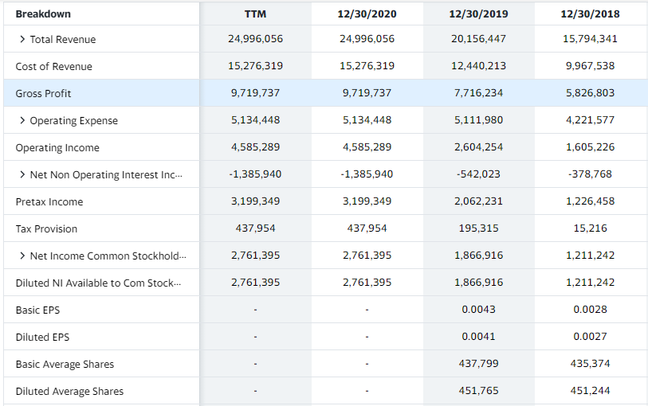

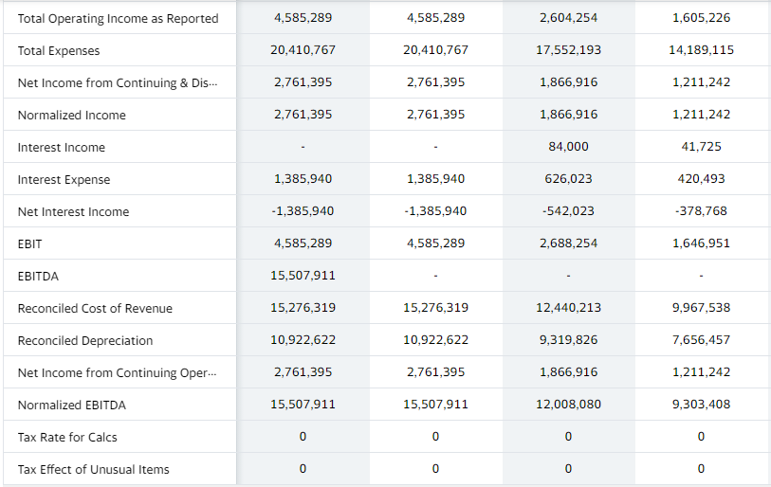

**Question #3:**

Device four plans for repayment of $25,000 in 5 years with interest at 15%

***Four plans for repayment of $25,000 in***

***5 years with interest at 15%***

1. **At the end of each year pay $5000 plus interest dues:**

Interest rate at the end of 1st year=$25000(0.15) = $3750

Payments at the end of 1st year= $5000 + $3750= $8750

Interest rate at the end of 2nd year=$20000(0.15) =$3000

Payments at the end of 2nd year= $5000 + $3000= $8000

Interest rate at the end of 3rd year=$15000(0.15) =$2250

Payments at the end of 3rd year= $5000 + $2250= $7250

Interest rate at the end of 4th year=$10000(0.15) =$1500

Payments at the end of 4th year= $5000 + $1500= $6500

Interest rate at the end of 5th year=$5000(0.15) =$750

Payments at the end of 5th year= $5000 + $750= $5750

Total payments= 8750+8000+7250+6500+5750=$36250

Total interest payments= 3750 + 3000+ 2250+ 1500+750= 11250

1. **Pay interest due at the end of each year and principal at the end of 5 years**

Interest rate at the end of each year =$25000(0.15) = $3750

Principal payment at the end of five years = $25000

Total interest payment at the end of five years= $3750 + $3750+ $3750+ $3750+$3750= $18750

Total payments= $25000 + $18750= $43750

1. **Pay in 5 equal end of year payments**

Total payments due to paying at the end of each year are

Total payments= 8750+8000+7250+6500+5750=$36250

Pay in 5 equal end of year payments = $7250

1. **Pay principal and interest in one payment at the end of 5 years**

Total interest payment of five years= $3750 + $3750+ $3750+ $3750+$3750= $18750

Total payments= $25000 + $18750= $43750

**Conclusion:**

Among all of four plans, plan one and plan three are working almost same however in my opinion plan one is better.